Choose the Database you want access to

* TCGA
* NCBI Tumor
* NCBI Cell Lines

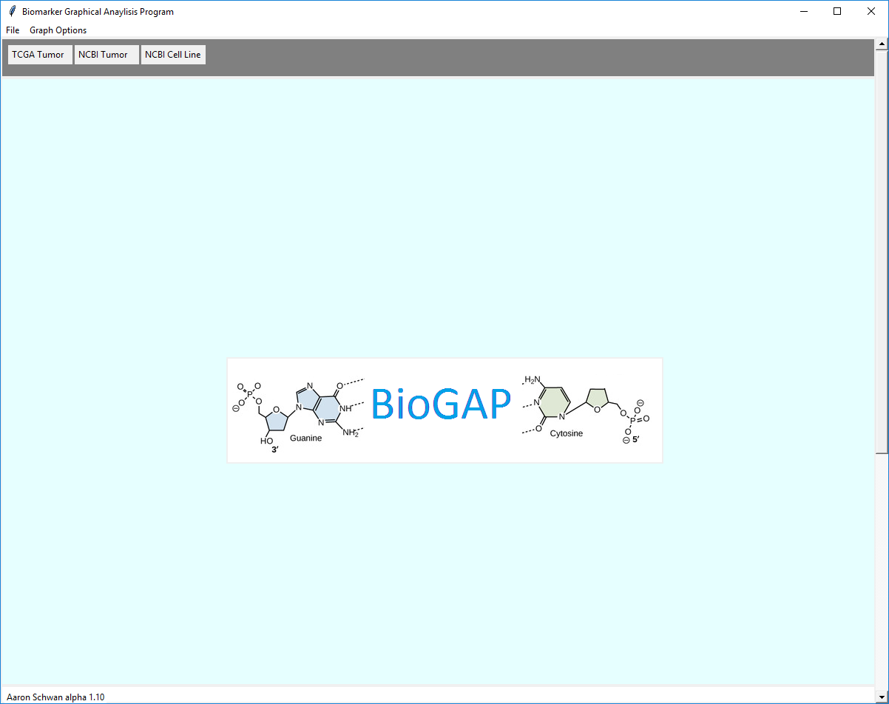

# TCGA Database Usage:

* Search Gene
  + Normal Search
  + Advanced Search
* Correlations
  + Normal
  + Heat map
* Kaplan Meier
  + Normal Kaplan
  + Retrieving p-value
  + Automated Kaplan Meier’s
* Stage Graph
* Expression Graph

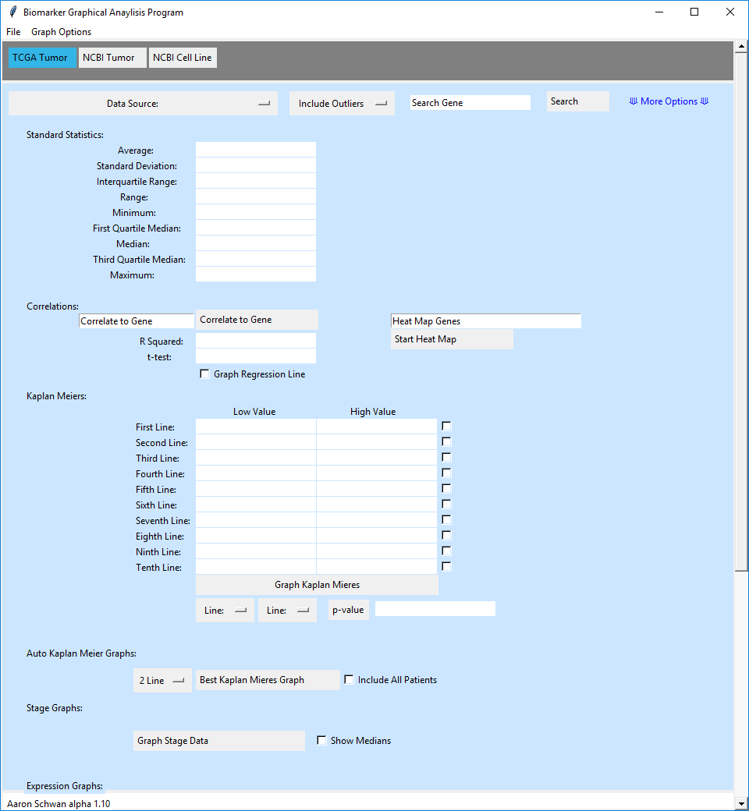

# Search Gene:

# Normal gene Search:



4

3

2

1

1. Choose Data Source

2. Decide to include or exclude outliers a. Exclude Outliers works on a standard statistical measure that says anything 1.5 times the Interquartile away from the median of the third and first quartile is an outlier.

3. Type gene into text box (if the gene doesn’t work try it under a different name and hit Search Gene.)

4. Hit “Search” button.

# Advanced gene Search:



1

1. Select “More Options”

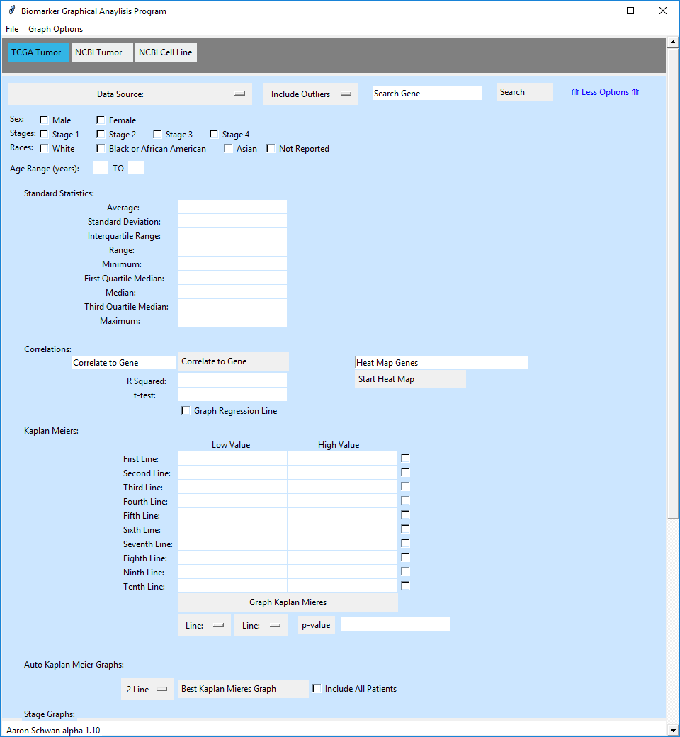

2. Select all requirements you want the individuals to have (sex, stage, race, age).

*One of each field must be selected or else no data will fit the requirements.

** if no data comes through with all fields having a selection there is no individual meeting all requirements.

*** when “Less Options” is selected the requirements are reset to allow all patient data with expression data to be used.

# Correlations:

# Normal:

3



2

1. Select a gene with gene search function.
2. Choose a gene to correlate this uses all requirements set up in your initial gene search.
3. Press correlate button to have graph made.
   1. If a linear regression line is wanted select the check box “Graph Regression Line”
4. The box shows where the linear regression coefficient and t-test values are displayed automatically once graphed.

When graphed it will display a graph like these: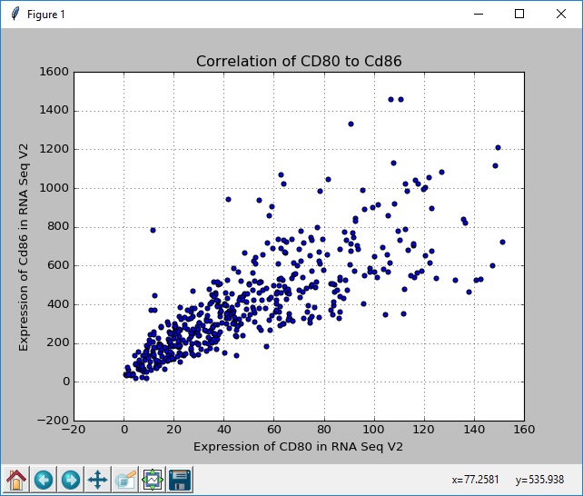

*Without linear regression line

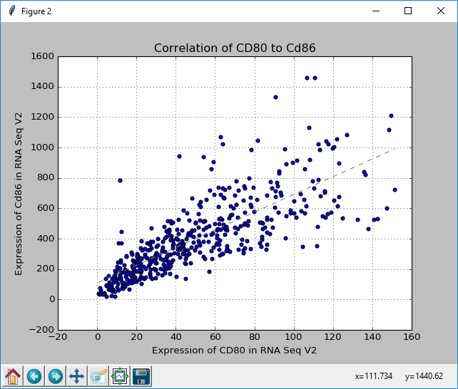

*With linear regression line

# Heat map:



*As with normal correlation graphs the heat map function uses the requirements set by gene search in the initial search unlike correlations it doesn’t use the gene search box only genes typed into the “Heat Map Genes” entry box.

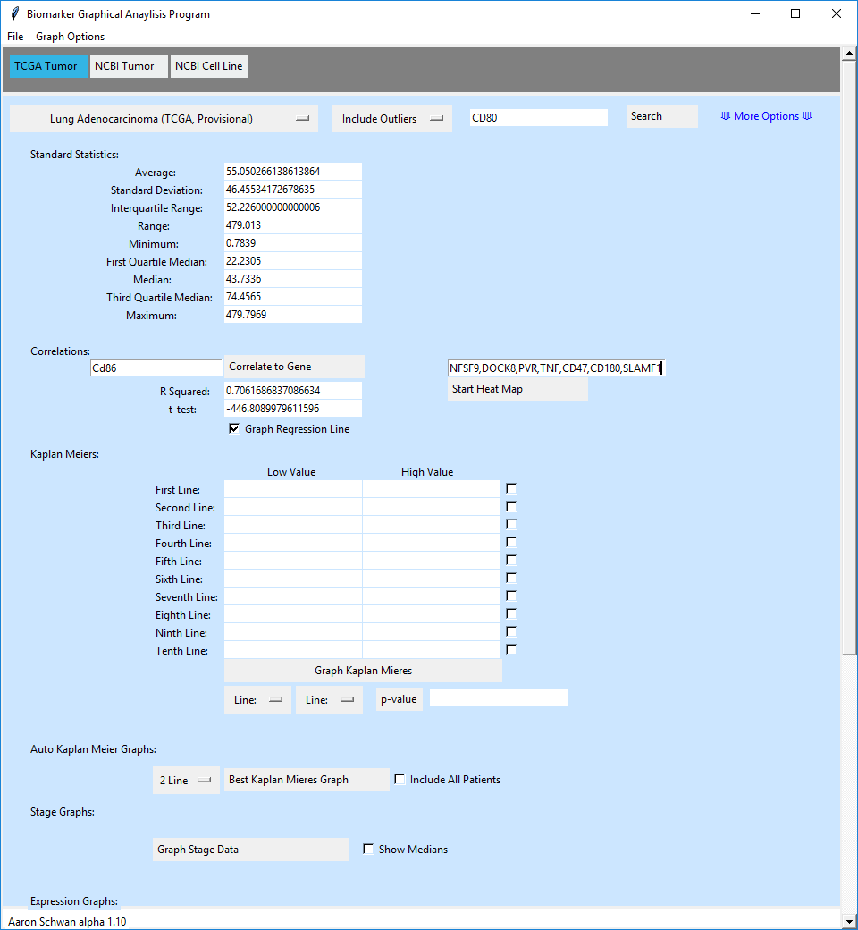

Once genes are typed into “Heat Map Genes” entry box when you hit the “Start Heat Map” button it begins to make the heat map.

*this may take several minutes

When done it graphs the data in a normal matrix.

Red = good correlation above .8

Yellow = correlation above .7

Green = correlation above .5

Blue = correlation below .5

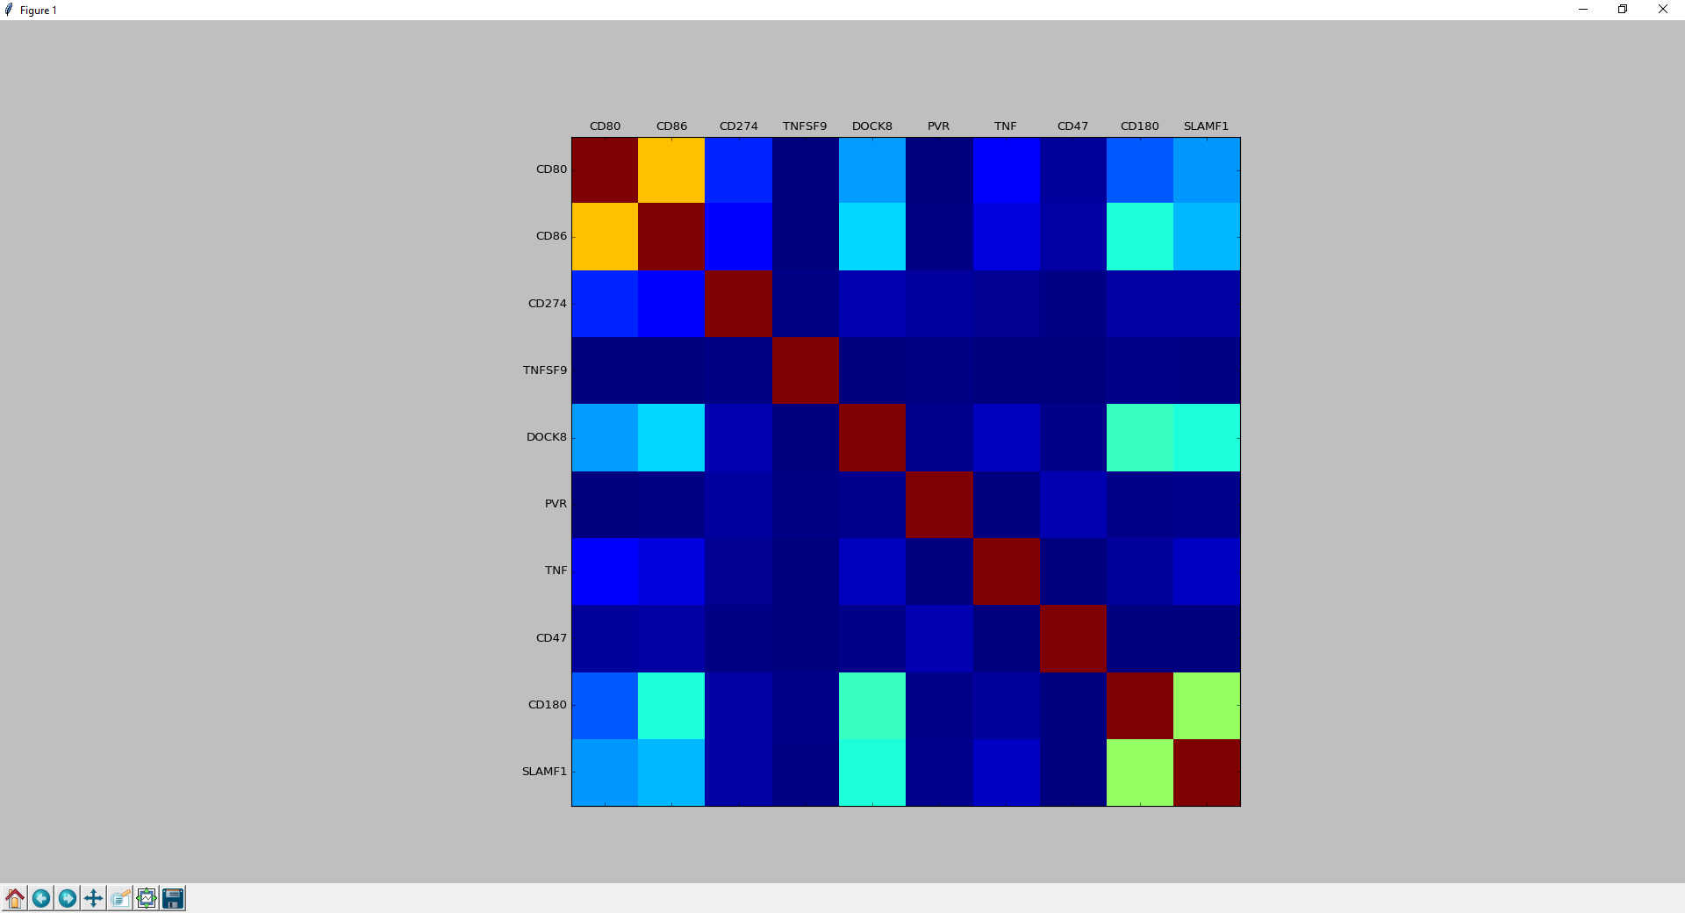

# Kaplan Meier Graphs:

# Normal Kaplan:

3

1

2

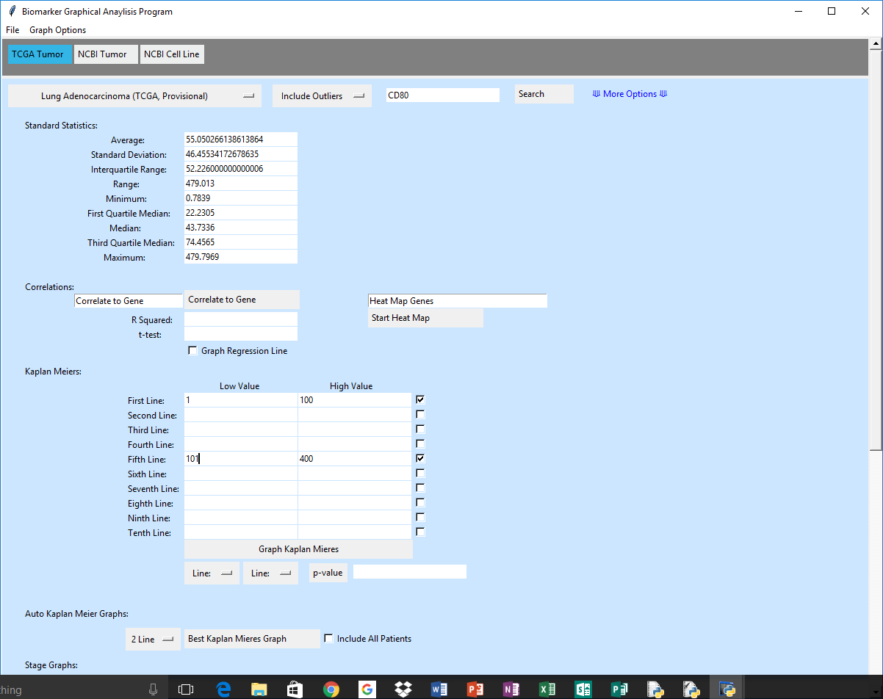

1. Type in low values you want to graph in “Low Value” column.
2. Type in High values you want to graph in “High Value” column.
3. Choose what expressions you want to graph with the check boxes.

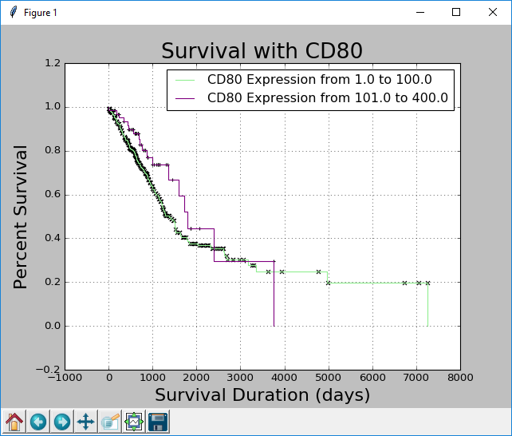

# Retrieving p-value:

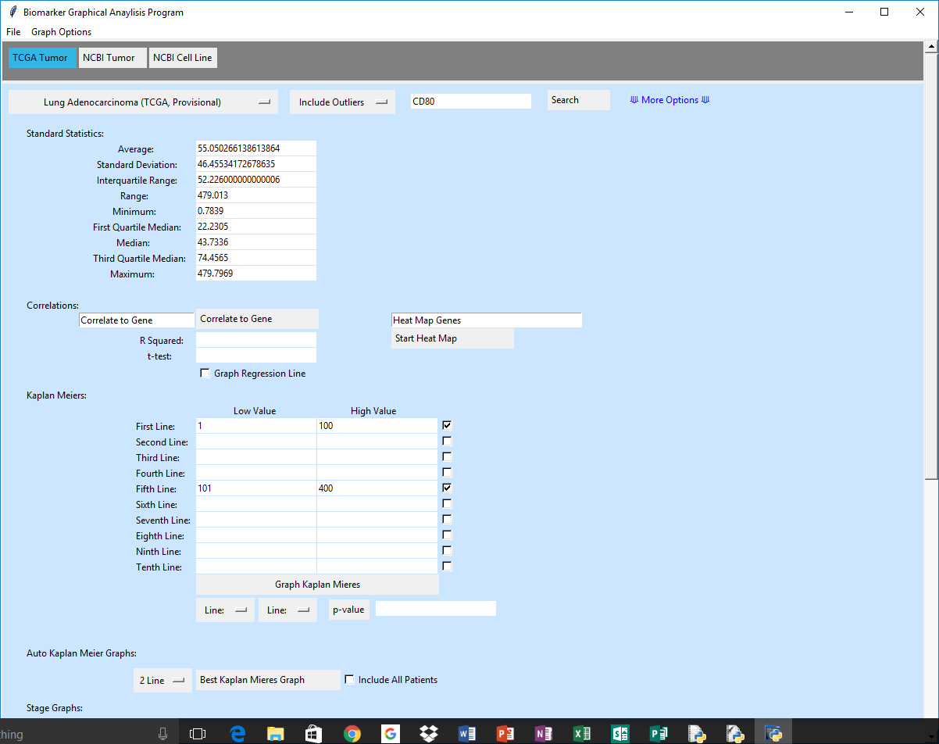

5

4

3

2

1. Graph a Normal Kaplan Meier with at least two lines.
2. Select first line.
3. Select second line to compare using the log rank test.
4. Hit the “p-value” button.
5. p-value displayed in box next to “p-value” button.

It should end up looking something like this:

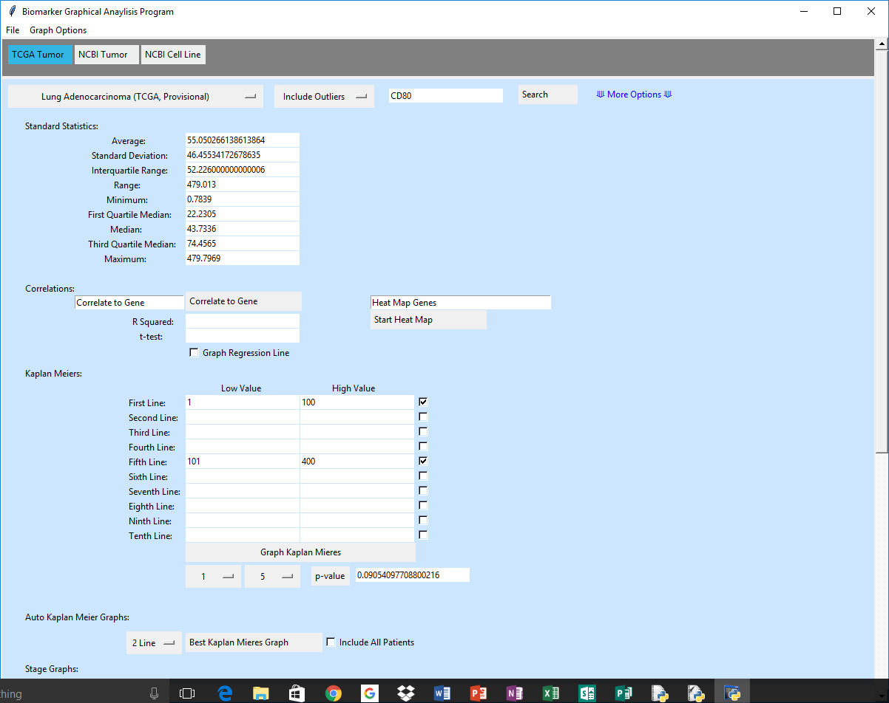

# Auto Kaplan Graphs:

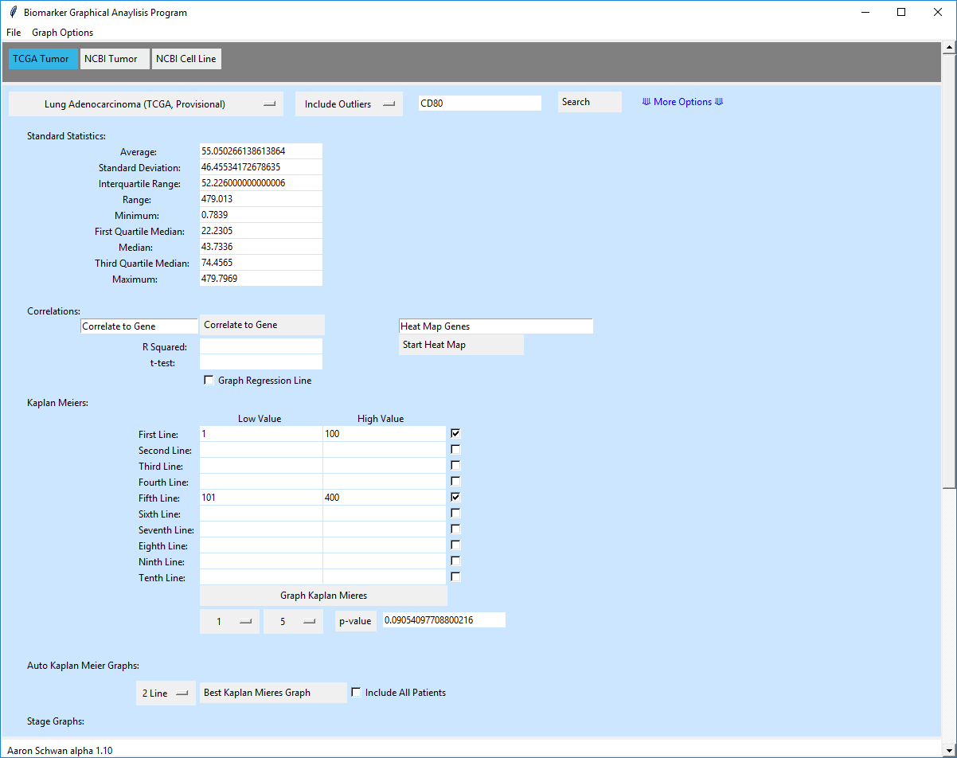

4

3

2

1. Search a gene.
2. Select amount of lines wanted (default 2).
3. Include all patients or not
   1. What this does is if you include all patients the graph will contain all people that the found by the program but if not checked it goes by the best p-value it can find.
4. Hit “Best Kaplan Meier’s Graph” button to begin graph.

It will return a graph similar to this:

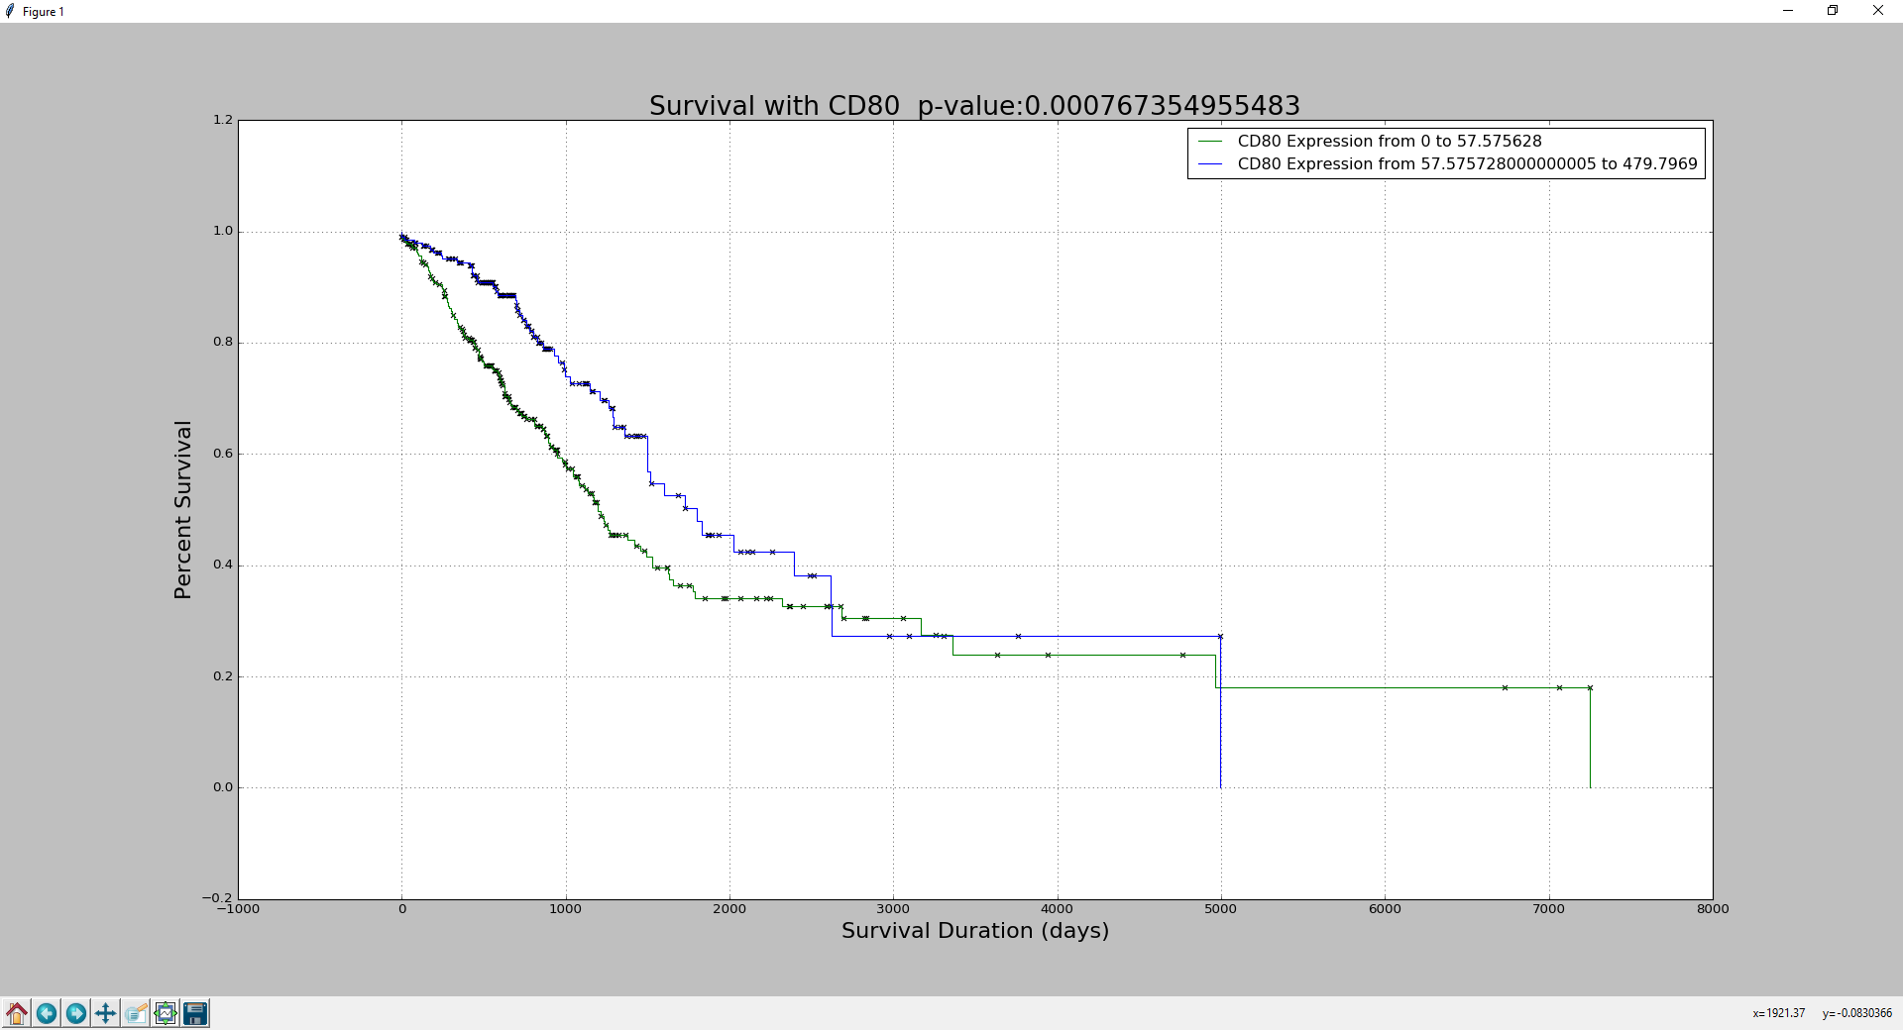

# Stage Graph:

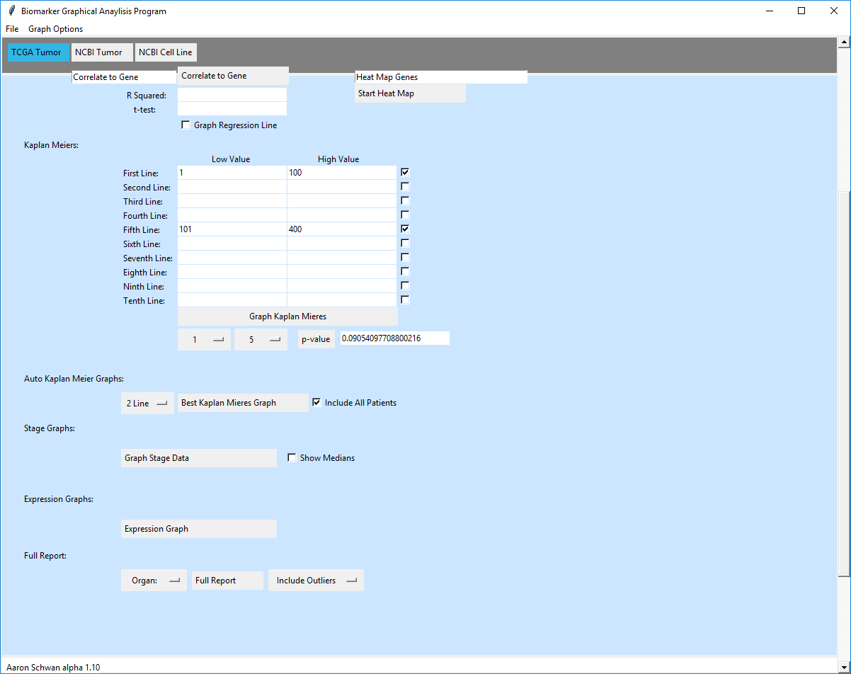

3

2

1. Search a gene.
2. Choose “Show Medians” or not.
3. Hit “Graph Stage Data”

The graph should look similar to this:

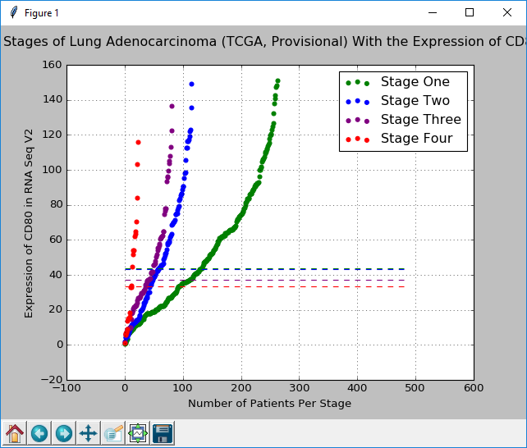

*With median lines

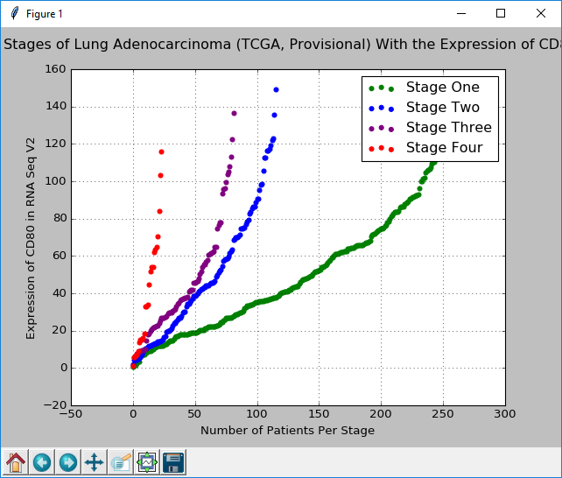

*Without median lines.

# Expression Graph:

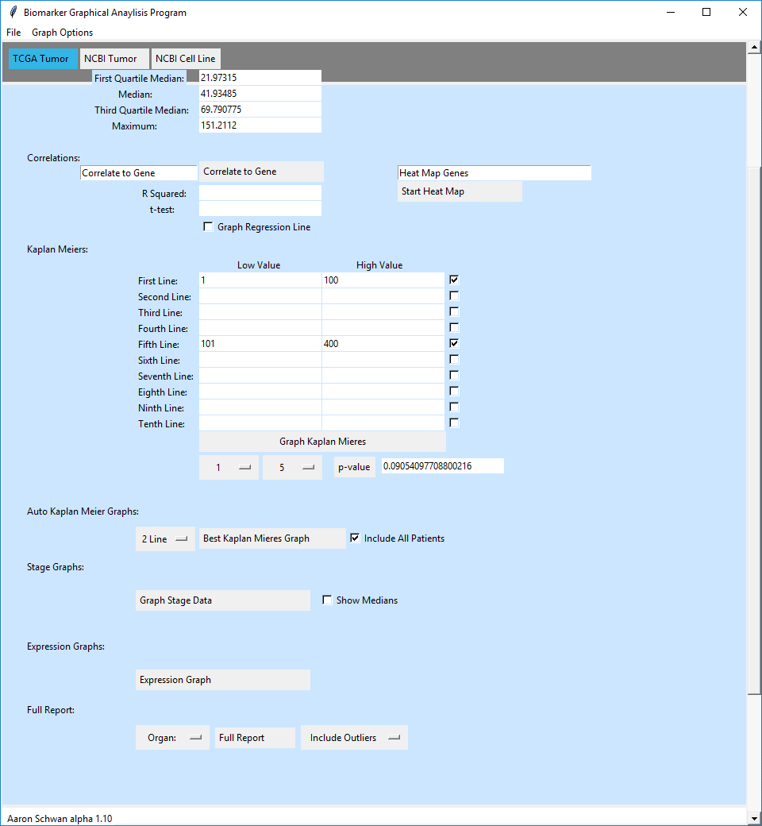

1. Search a gene.
2. Hit “Expression Graph”

The graph will look similar to this:

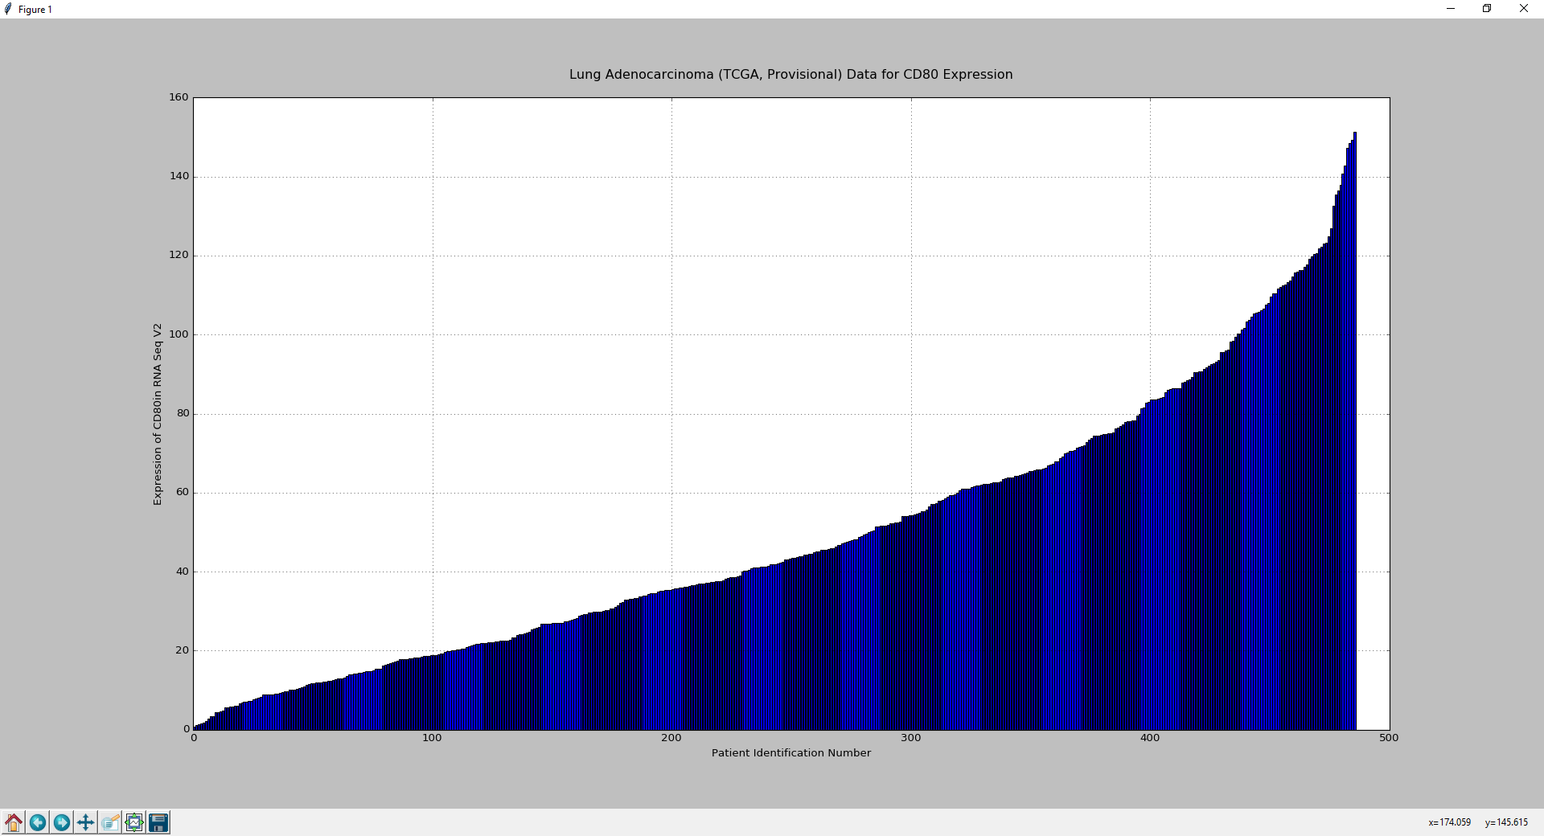

# NCBI Tumor Usage:

* Search Gene
* Correlations
  + Normal
  + Heat map
* Expression Graph

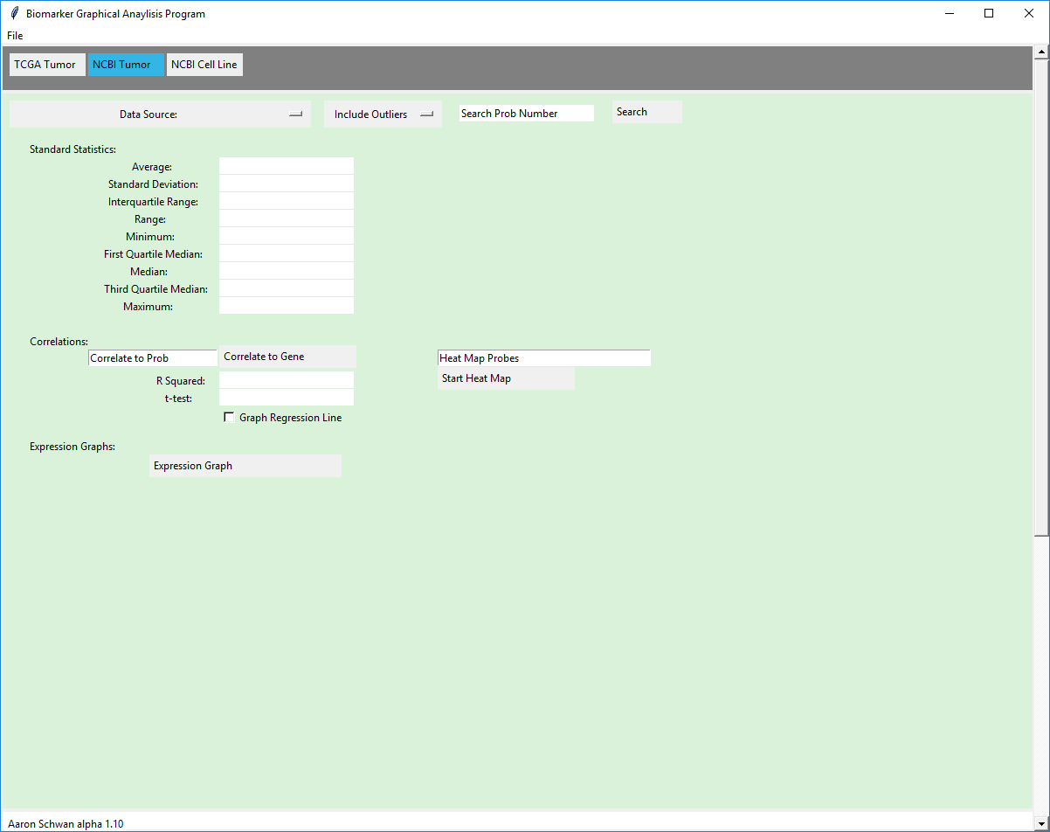

# Search Probe:



4

3

2

1

1. Choose Data Source

2. Decide to include or exclude outliers a. Exclude Outliers works on a standard statistical measure that says anything 1.5 times the Interquartile away from the median of the third and first quartile is an outlier.

3. Type gene into text box (if the gene doesn’t work try it under a different name and hit Search Gene.)

4. Hit “Search” button.

# Correlations:

# Normal:

3



2

1. Select a gene with Probe search function.
2. Choose a gene to correlate this uses all requirements set up in your initial Probe search.
3. Press correlate button to have graph made.
   1. If a linear regression line is wanted select the check box “Graph Regression Line”
4. The box shows where the linear regression coefficient and t-test values are displayed automatically once graphed.

The Graph should look similar to these:

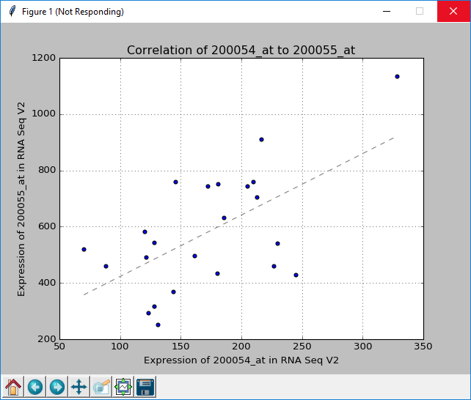

With linear regression line

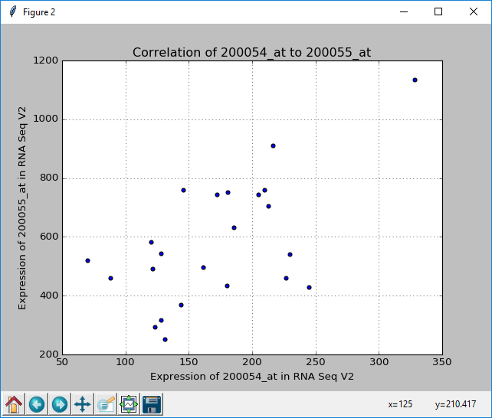

Without linear regression line.

# Heat Map:

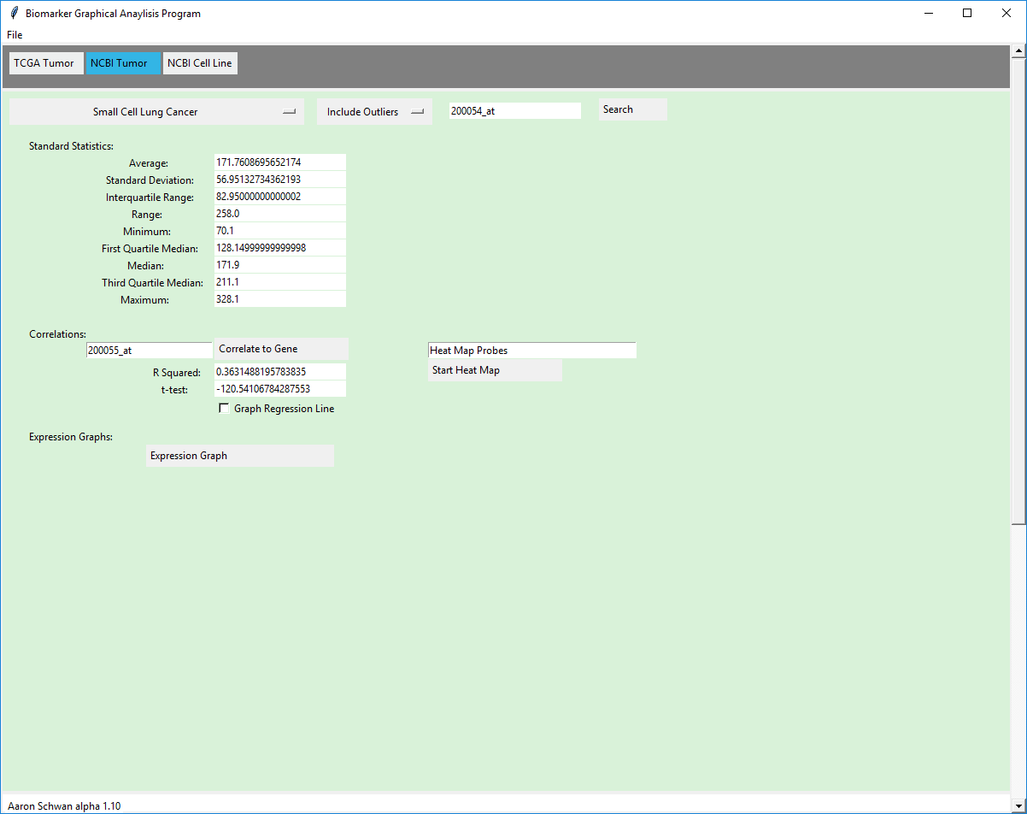

Once genes are typed into “Heat Map Genes” entry box when you hit the “Start Heat Map” button it begins to make the heat map.

*this may take several minutes

When done it graphs the data in a normal matrix.

Red = good correlation above .8

Yellow = correlation above .7

Green = correlation above .5

Blue = correlation below .5

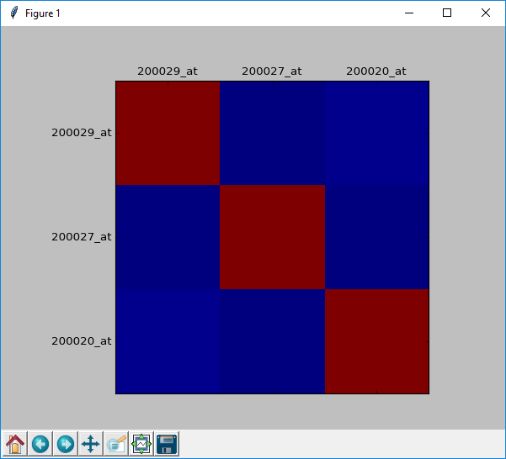

# Expression Graph:

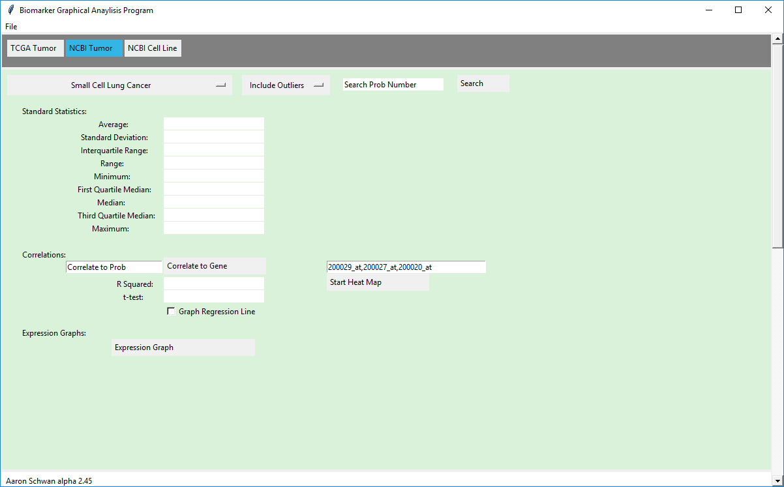

1. Search Probe
2. Hit Expression Graph

# NCBI Cell Line Usage:

* Search Cell Line
* Search Probe
* Expression Graph
* Heat Map

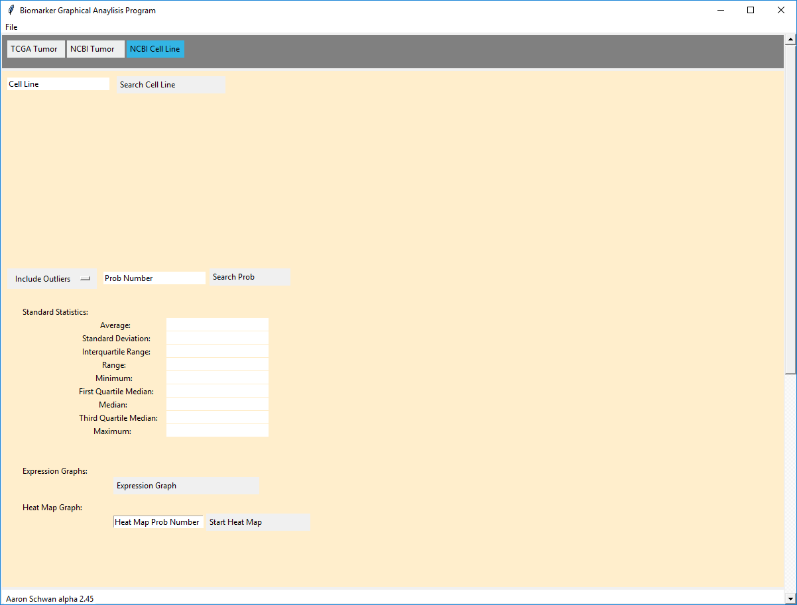

# Search Cell Line:



1. Type in cell line
2. Hit Search the program automatically finds any controls

It should return between 0 and 4 results:

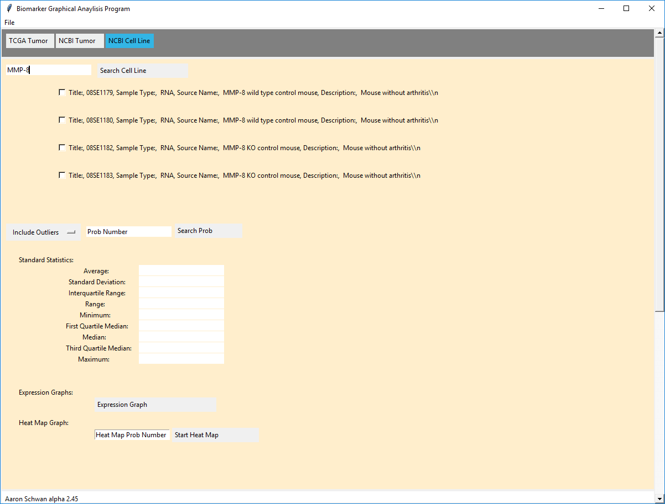

1. Select all choices that are appropriate for what you intend to look for

# Search Probe:

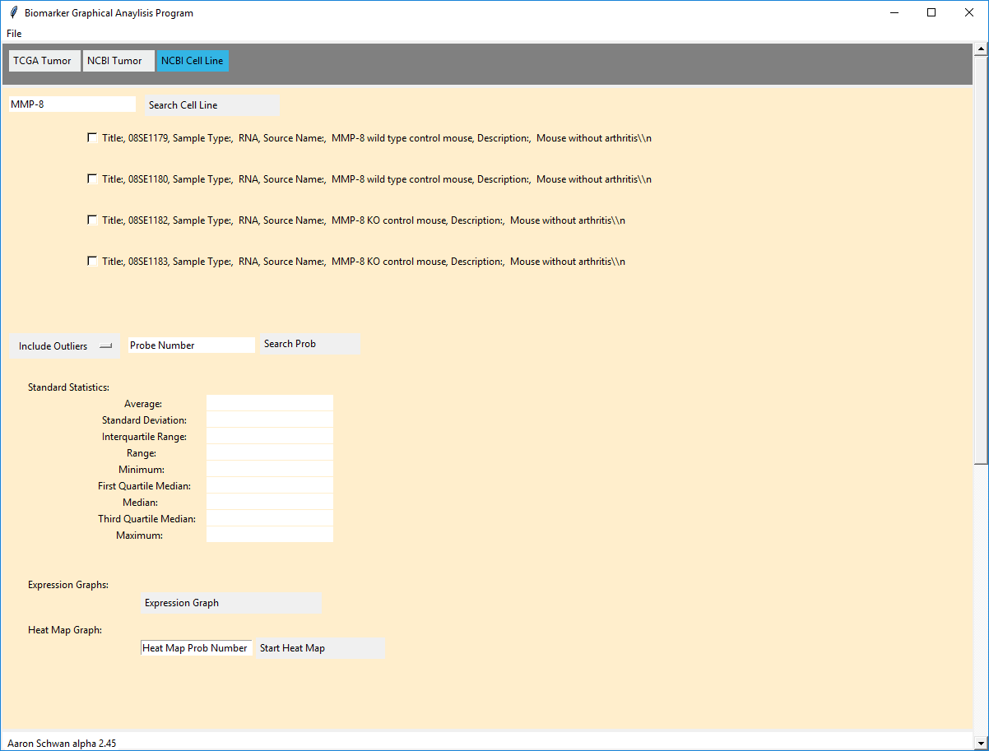

4

3

2

1. Search Cell line
2. Include/Exclude outliers
3. Choose probe
4. Hit “Search Probe”

# Expression Graph



1. Search Cell Line/ Search Probe
2. Hit “Expression Graph”

# Heat Map:

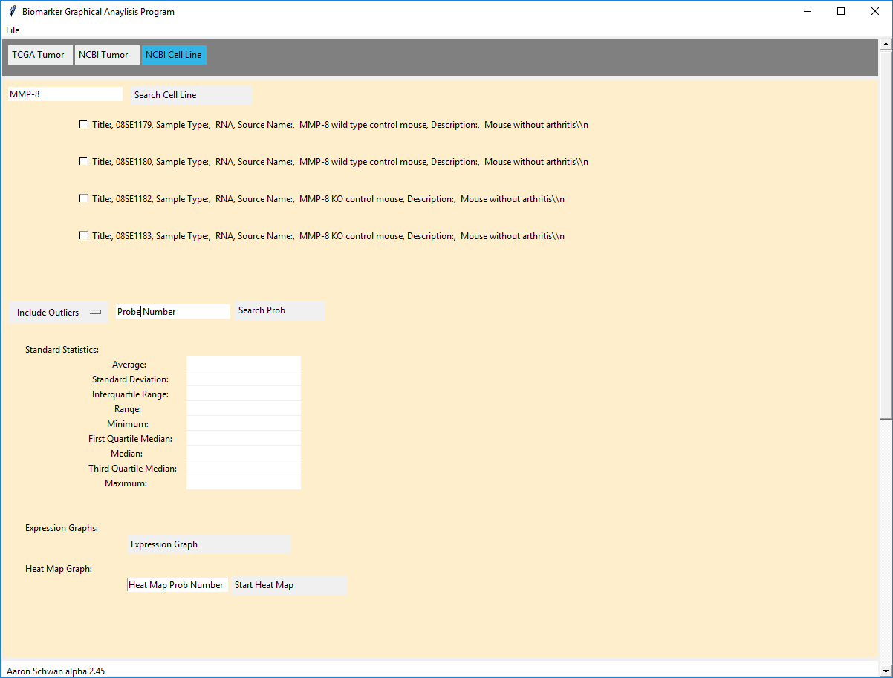

1. Choose a probe number and enter it into the “Heat Map Probe Number”
2. Hit “Start Heat Map”

*This is not a correlation heat map it is used to find which cell line will work best for research it automatically adds to itself the more it is used.

The graph should look similar to this:

